Ubuntu Documentation
- Create VM
- VM options are KVM Or Virtual box
Download Virtual box here https://www.oracle.com/virtualization/technologies/vm/downloads/virtualbox-downloads.html
Choose the windows version and pick the Oracle VirtualBox Base Packages - 7.2.6 version which is the latest version.
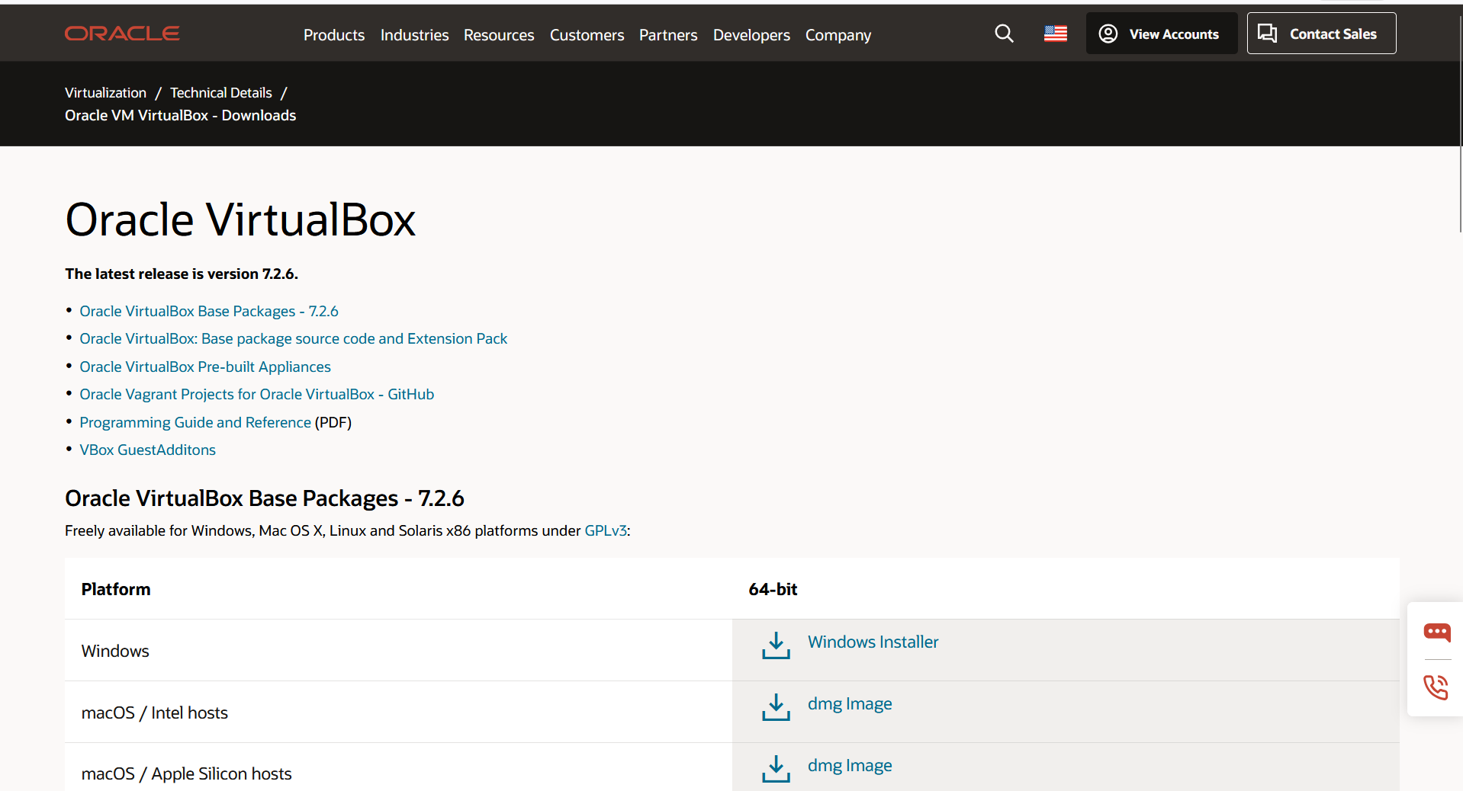

How to install the Virtual Box

How to create a VM
Open Oracle VirtualBox Manger
      - Click New
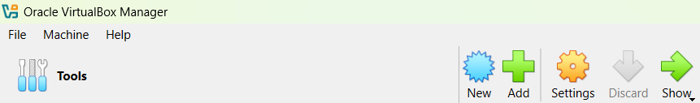

How to create VM with Ubuntu
Open Virtual Box Manger
Click on New
Your screen will look like that :
Complete blank space
Name : Ubuntu
Type : Linux
Subtype: Ubuntu
Version : Ubuntu (64 bit)

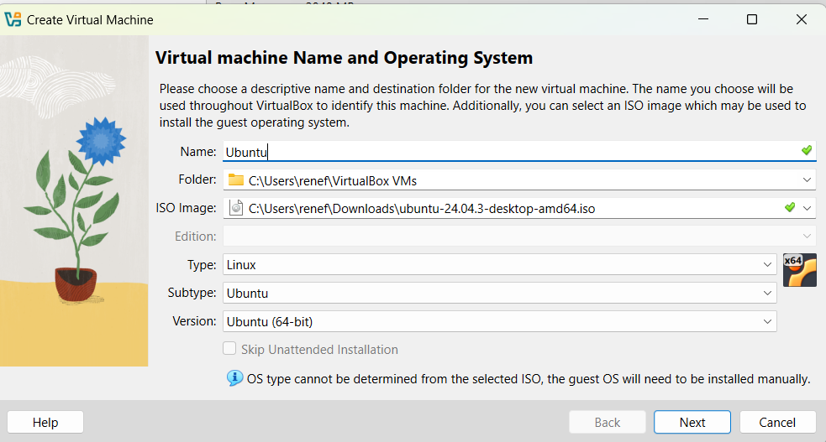

Show how to install OS
Click on ISO image
Your Screen will look like this 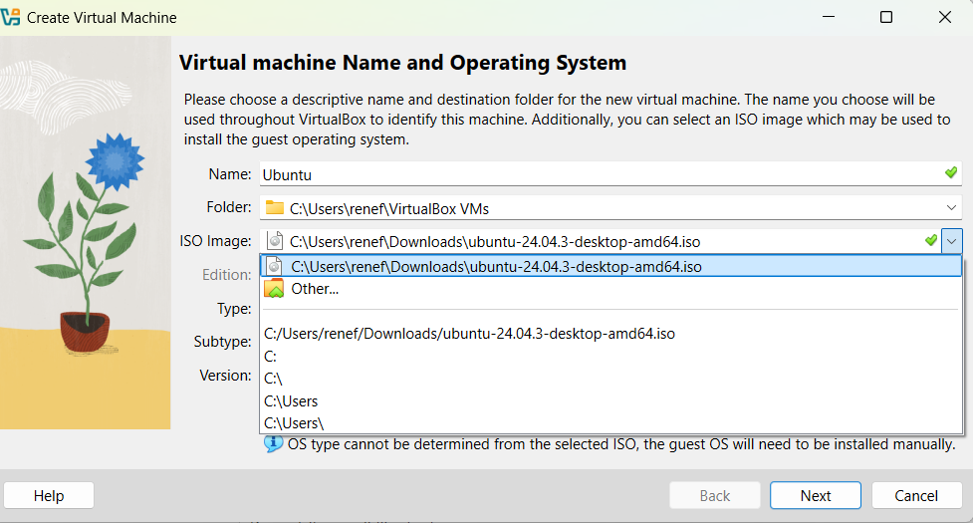

Pick ubuntu-24.04.3-desktop-amd64.iso
Then click Next.

Here you set up memory
Then Click Next
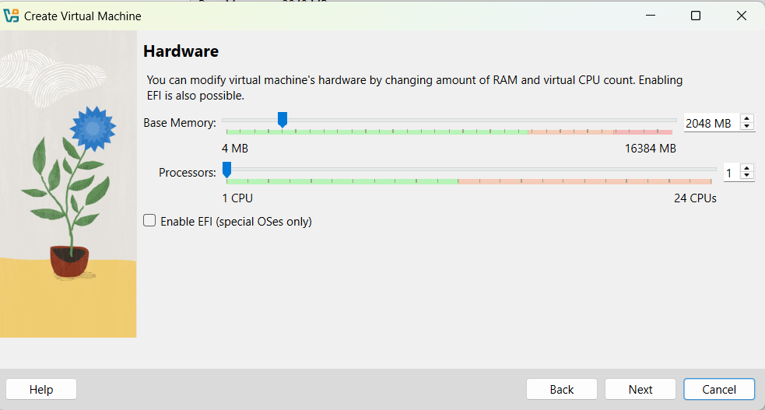

Setup virtual hard disk
Click Next
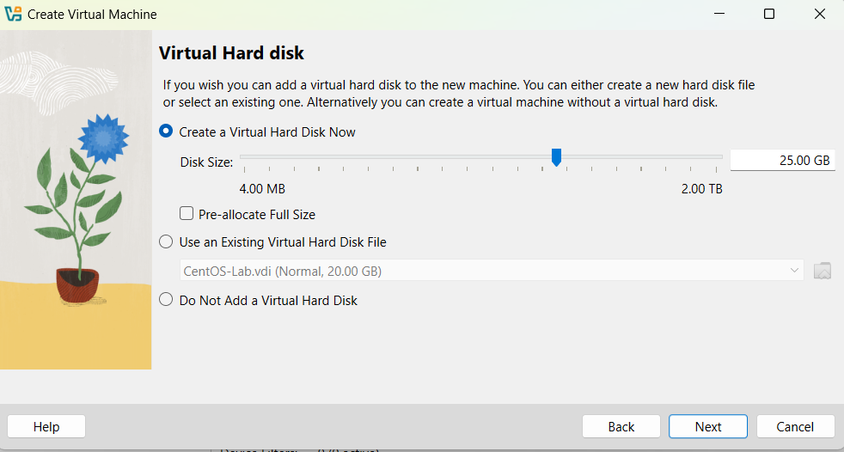


Click Finish

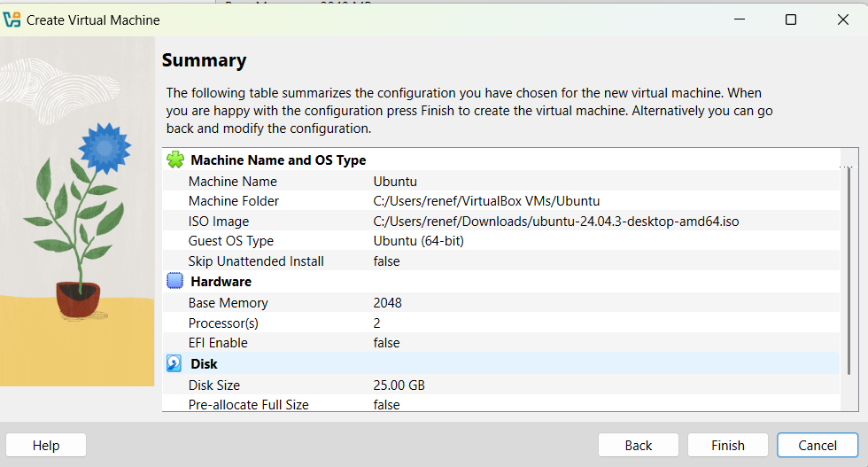

The new server will be shown on the Virtual Box Manager.
Double right click
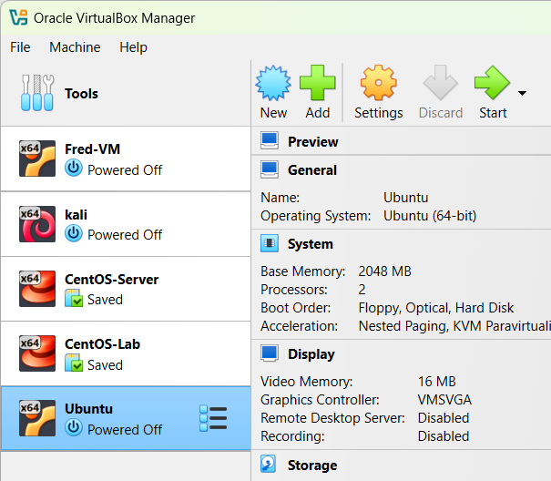

The server will be running for a while.
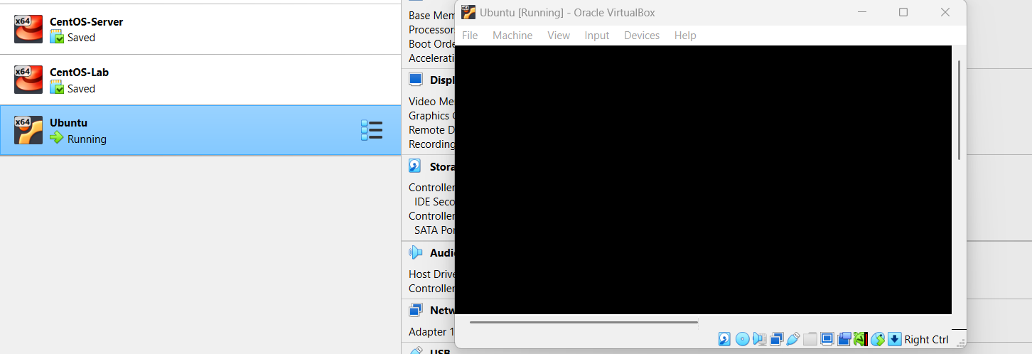

Set up language
Choose English or a language you comfortable with
Click Done
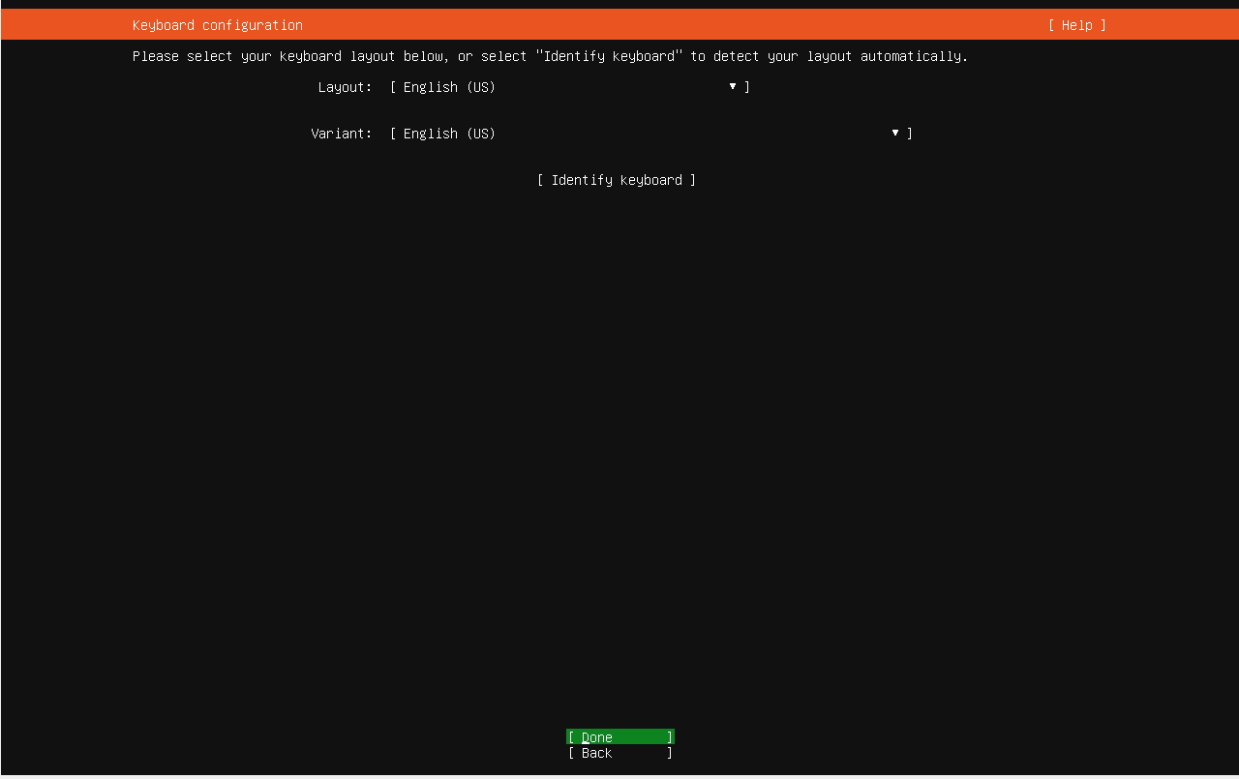

The screen will required to choose the type of installation
Choose ubuntu sever
Click Done
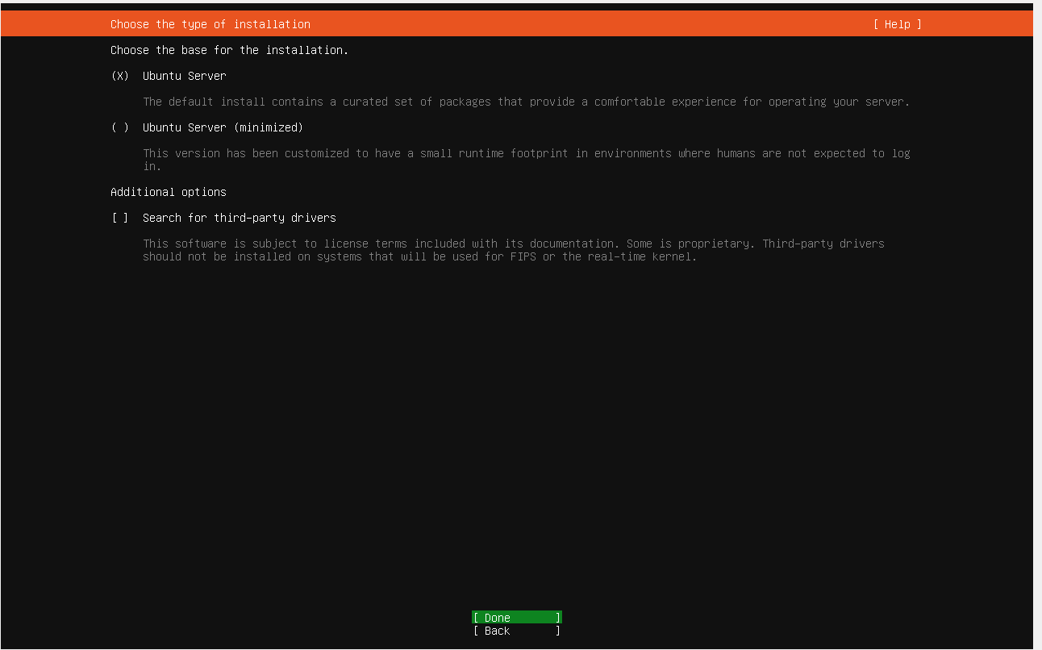

Configurate Network
Click Done

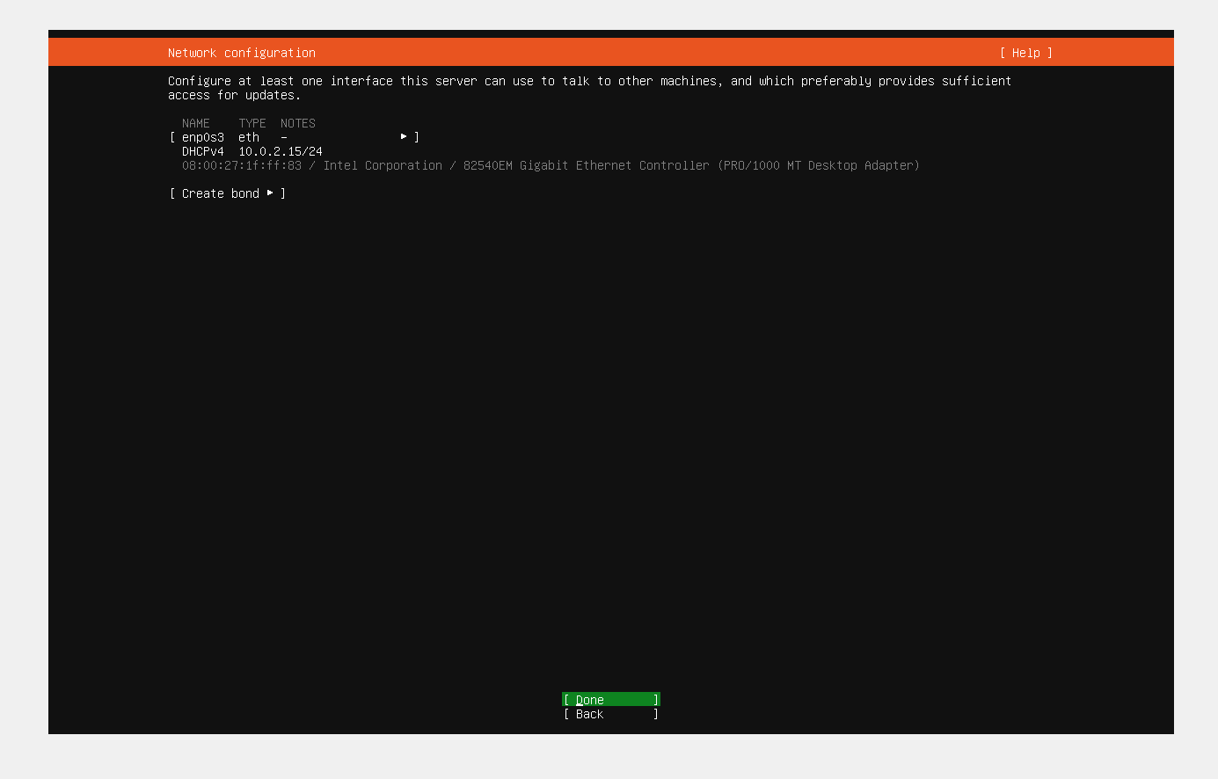

Leave proxy address blank
Click Done
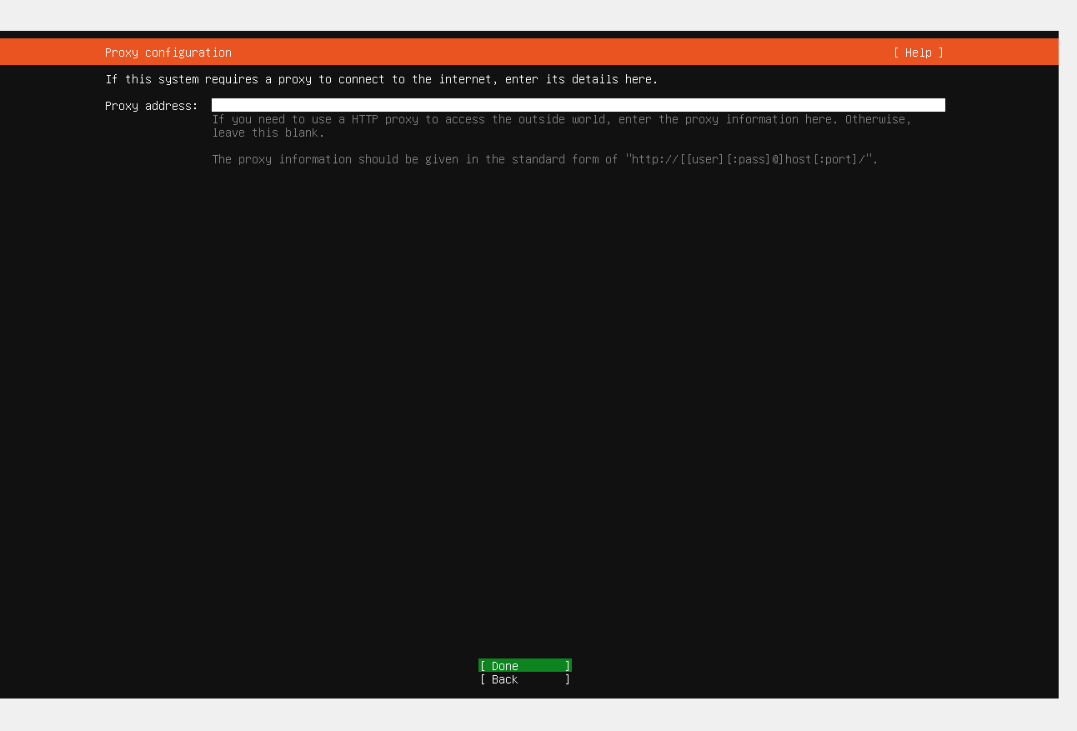

Mirror Adress will prompt the address automatically
Click Done
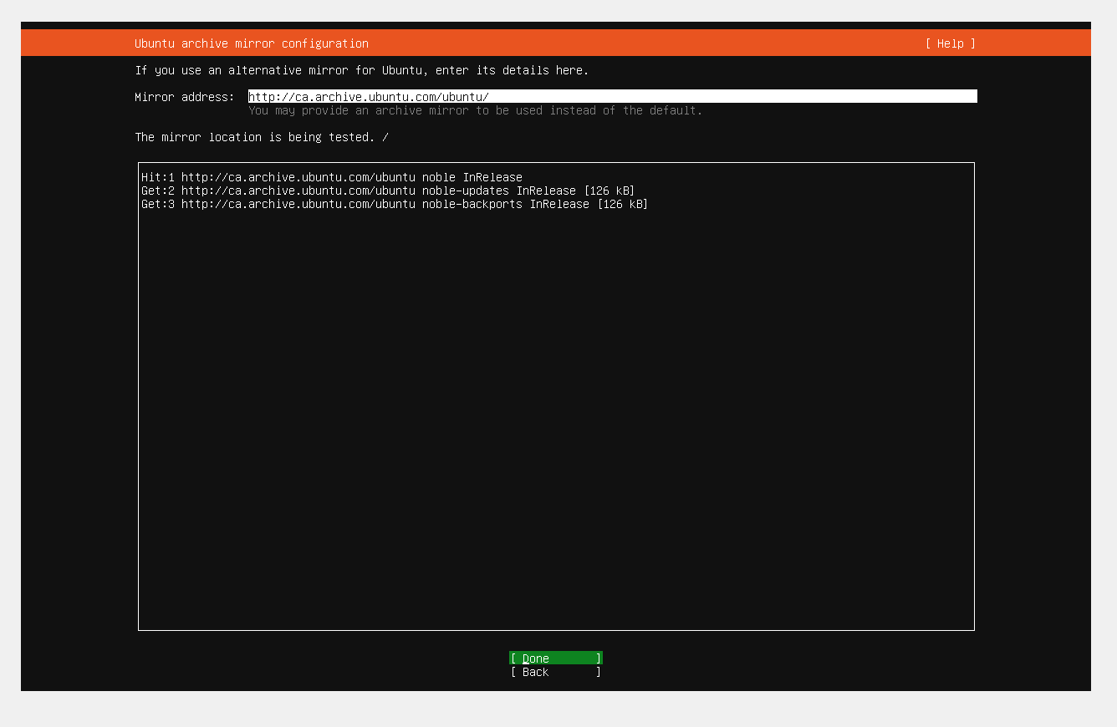

Click Done
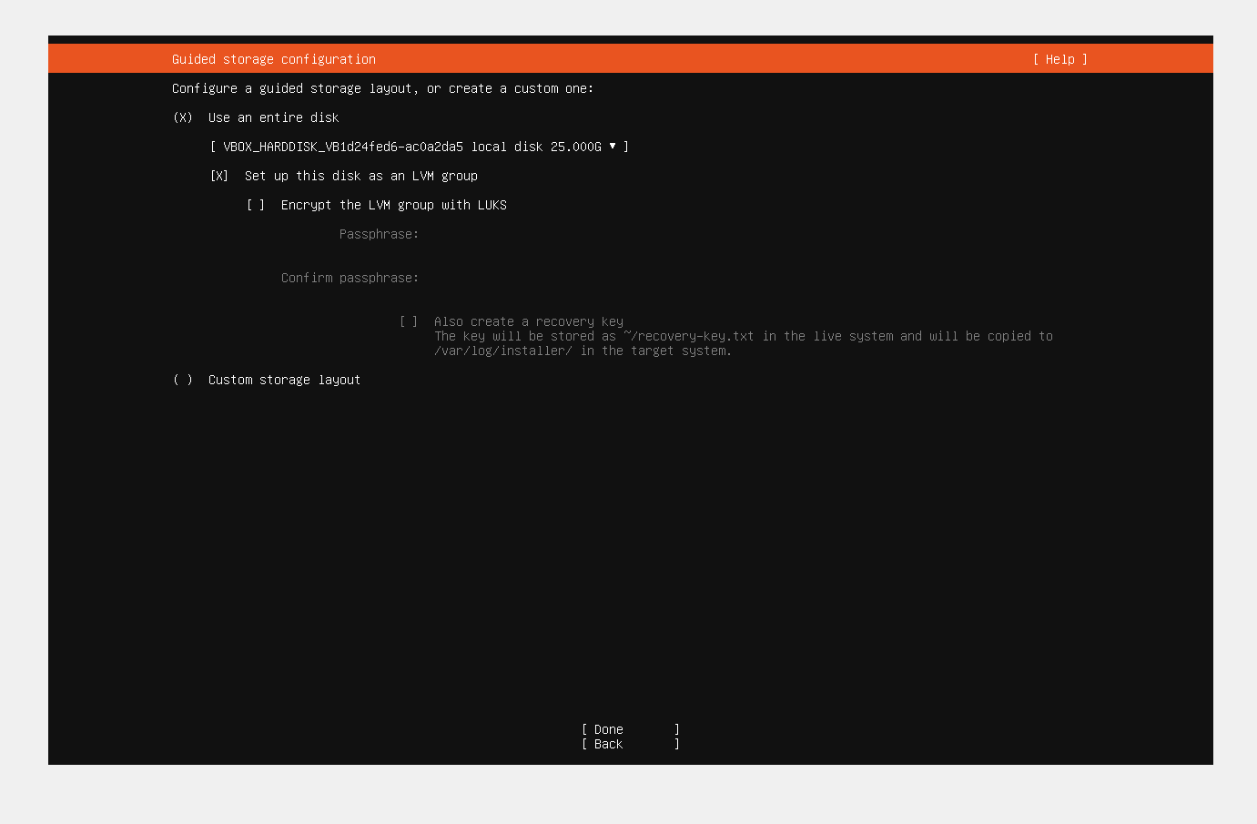

Click No
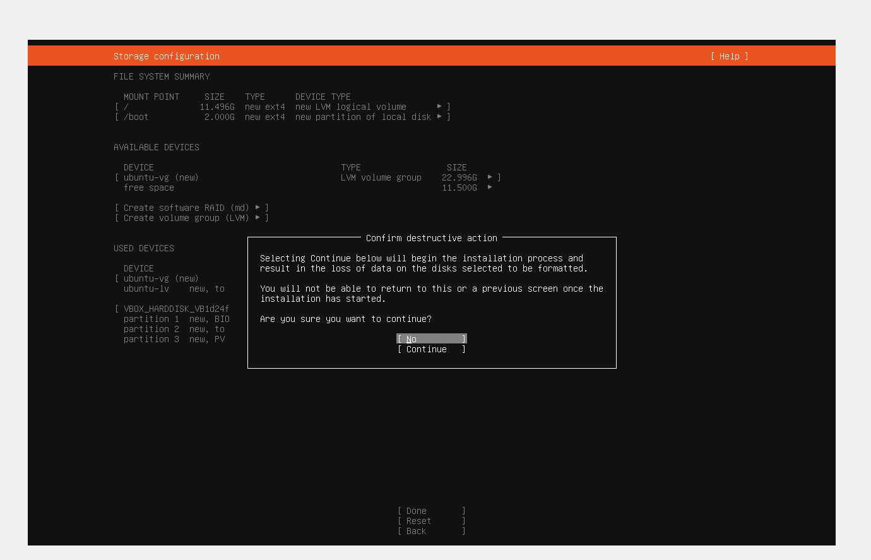

Complete your profile by entering the information
Click Done
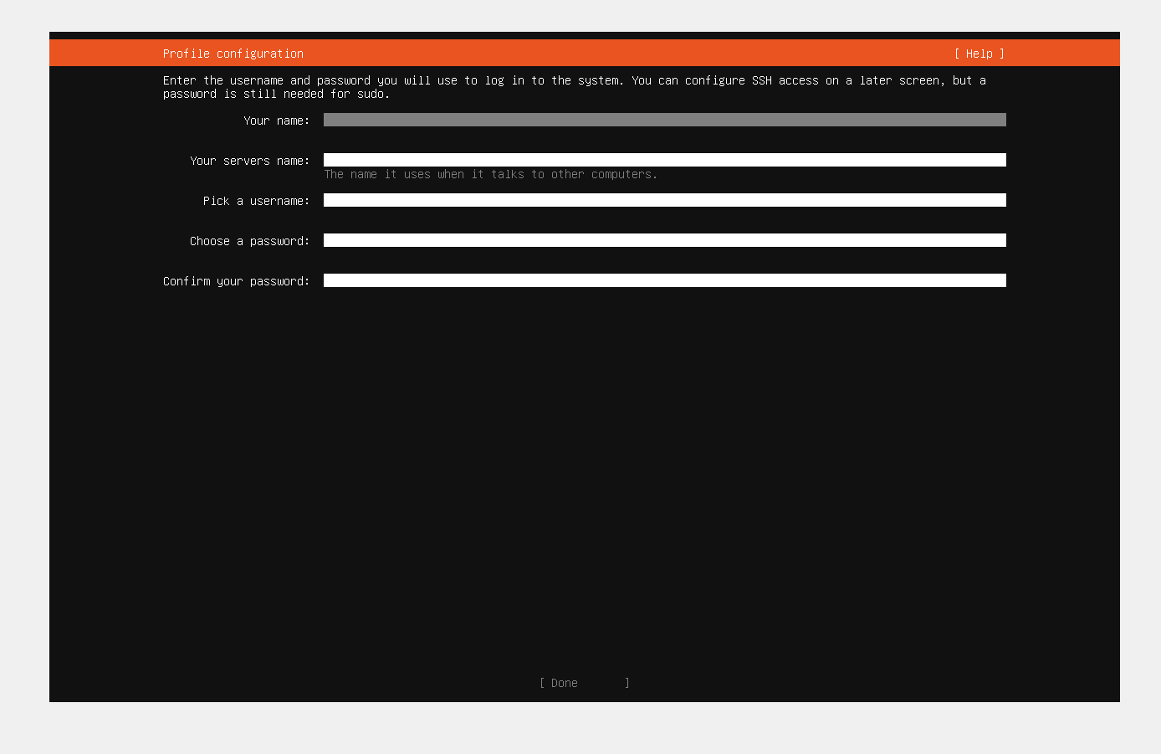

Click Done
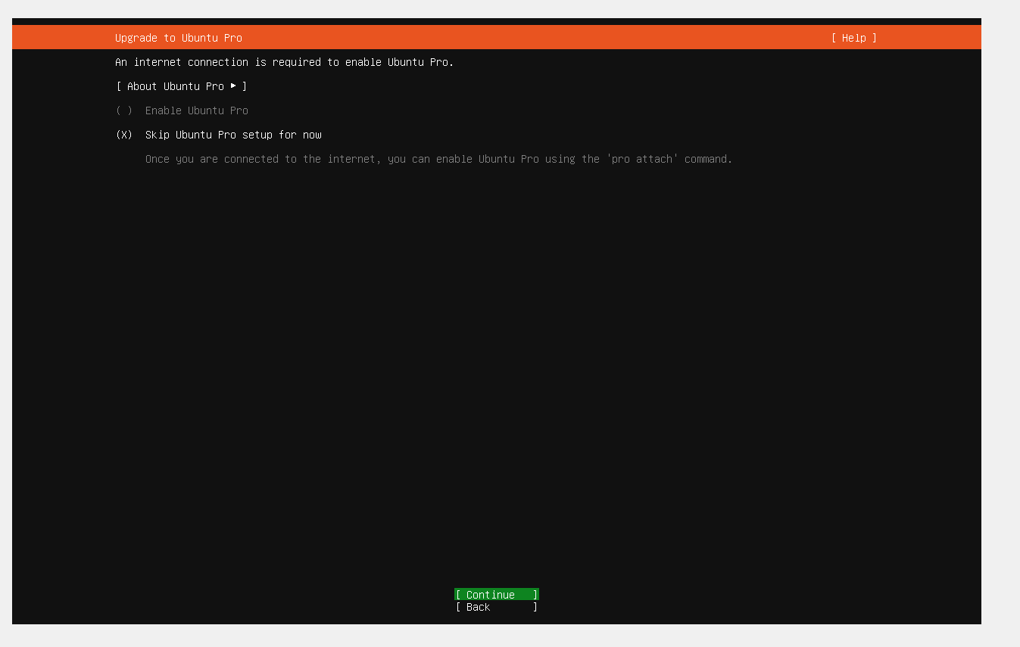

Click Done

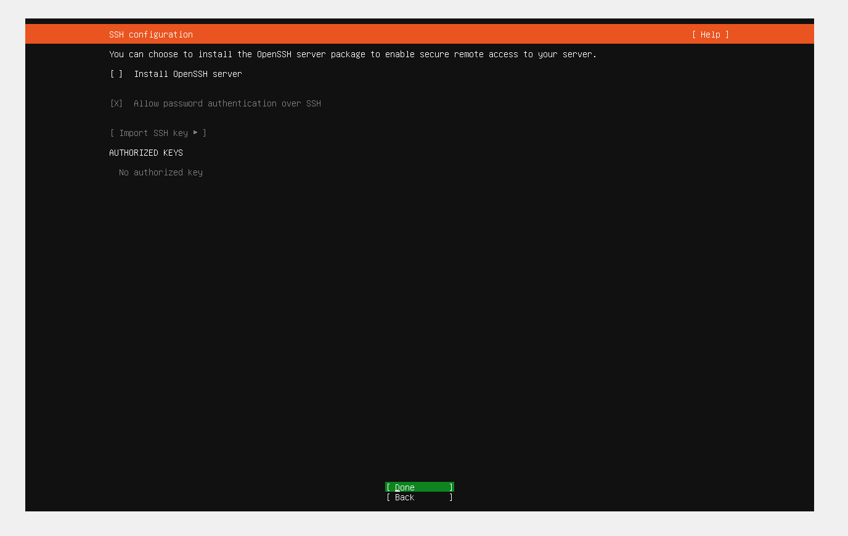

Installation complete
Click Reboot Now on the bottom

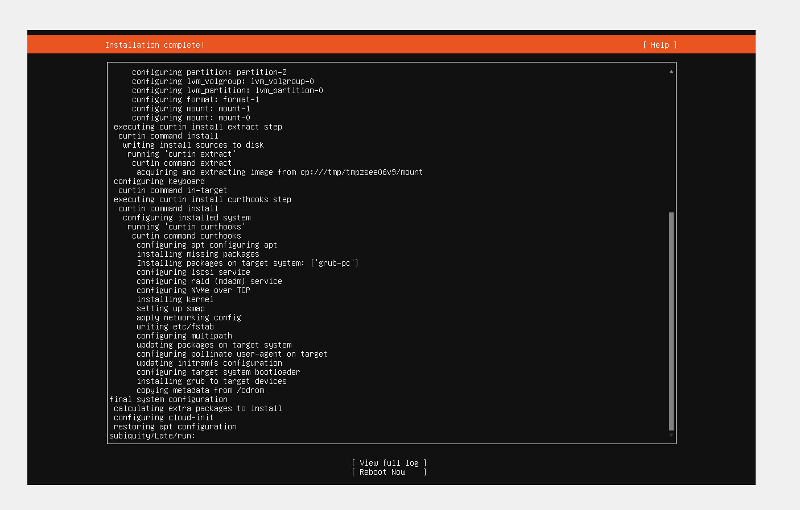

A login screen will prompt
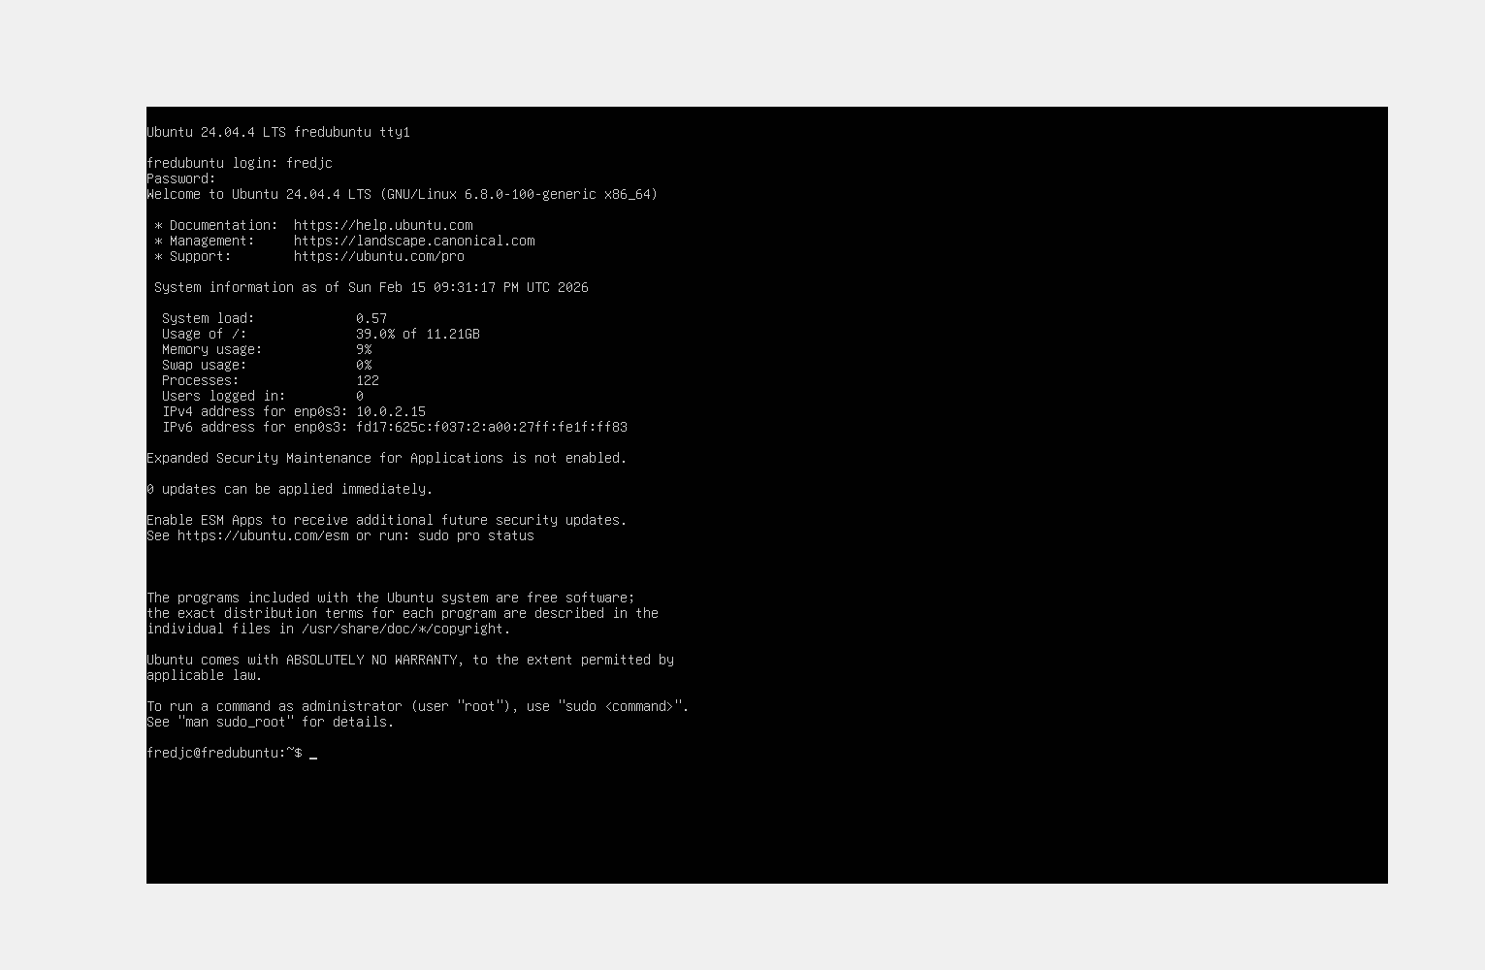

Show how share a file

Open Putty
Enter Information
Click Open

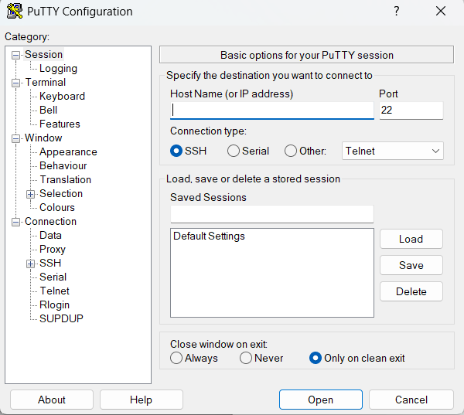

After entering information
The screen will prompt Warning Potential Security
Click Accept

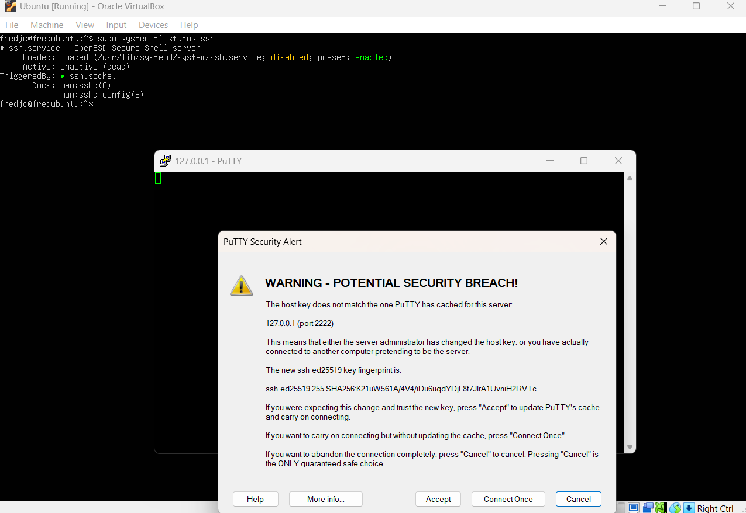

A login screen will prompt
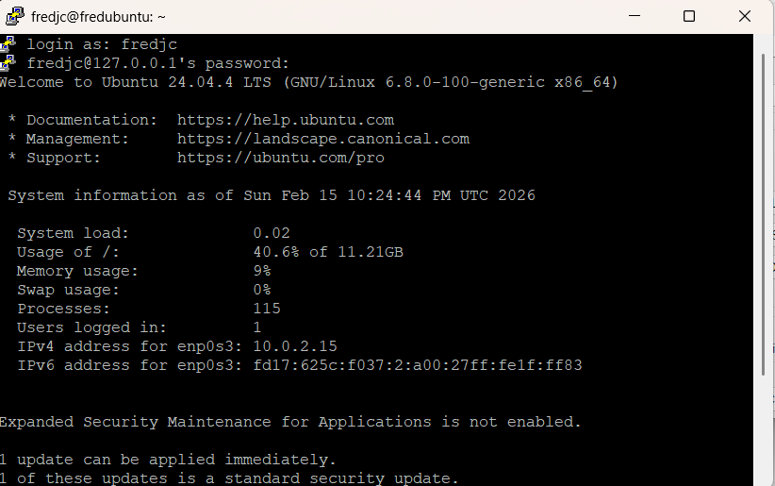

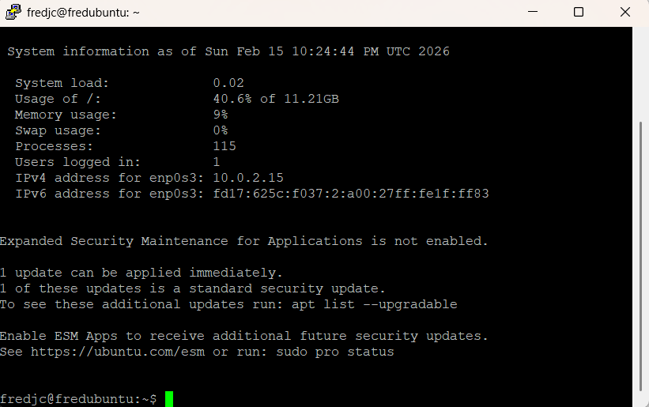

Alternative process on VM
Update your server with sudo apt command
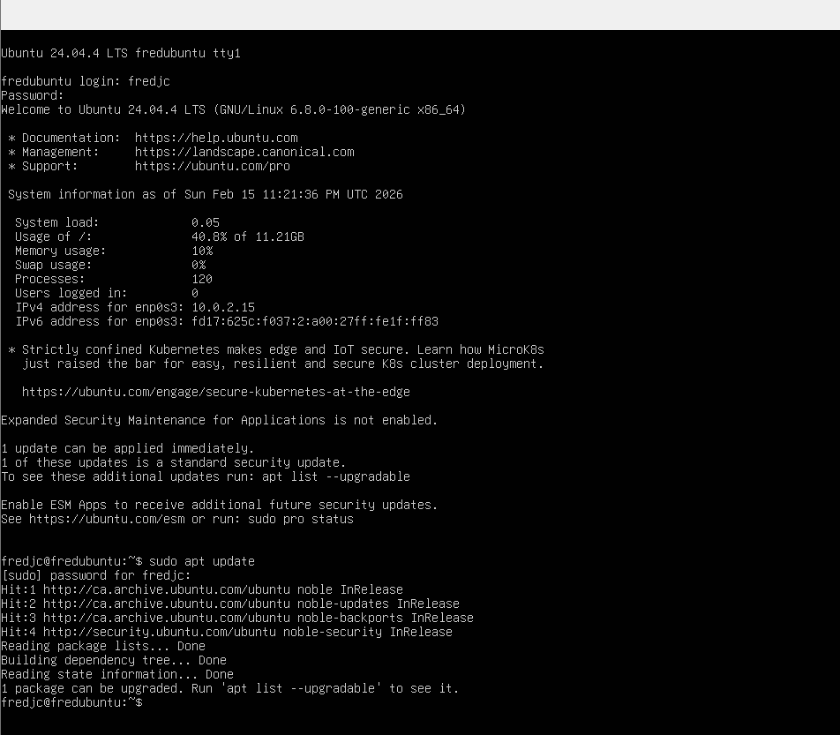

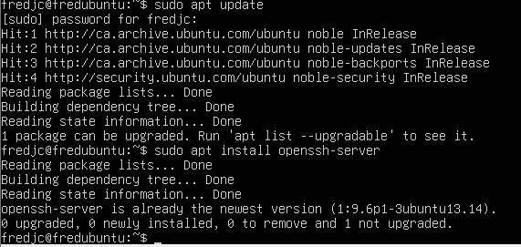

Verify ssh status with sudo systemctl status ssh

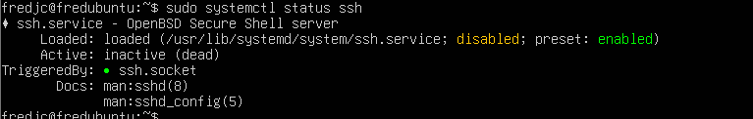

Status is active
It should be kept active and running for the putty process to be successful.
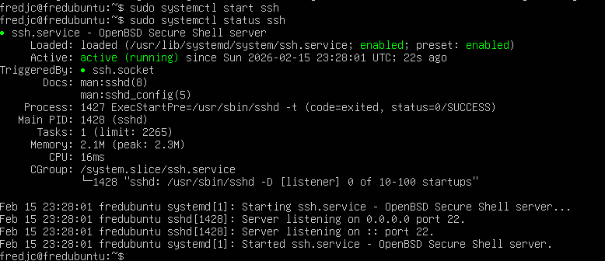
Open WinSCP
Add information (Information will be find on ubuntu server)
click save
Login
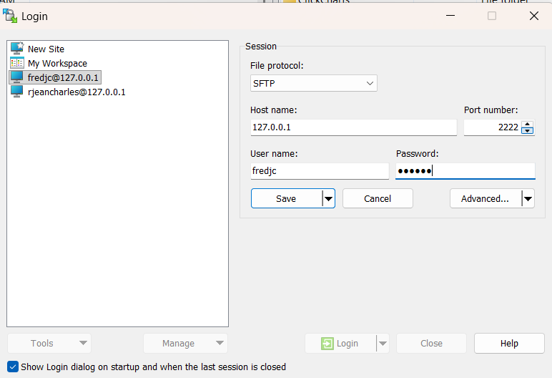

Your screen will prompt Warning – Potential security breach
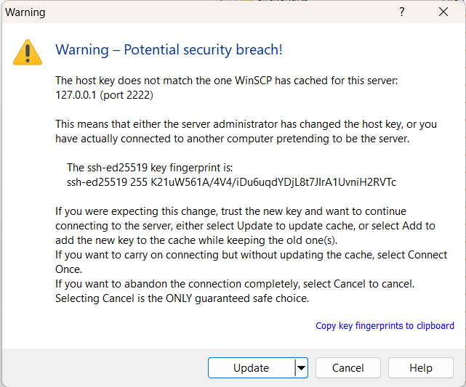

After the setup
To share file you will just have to drag the file from the windowns server to ubuntu server on WinSCP
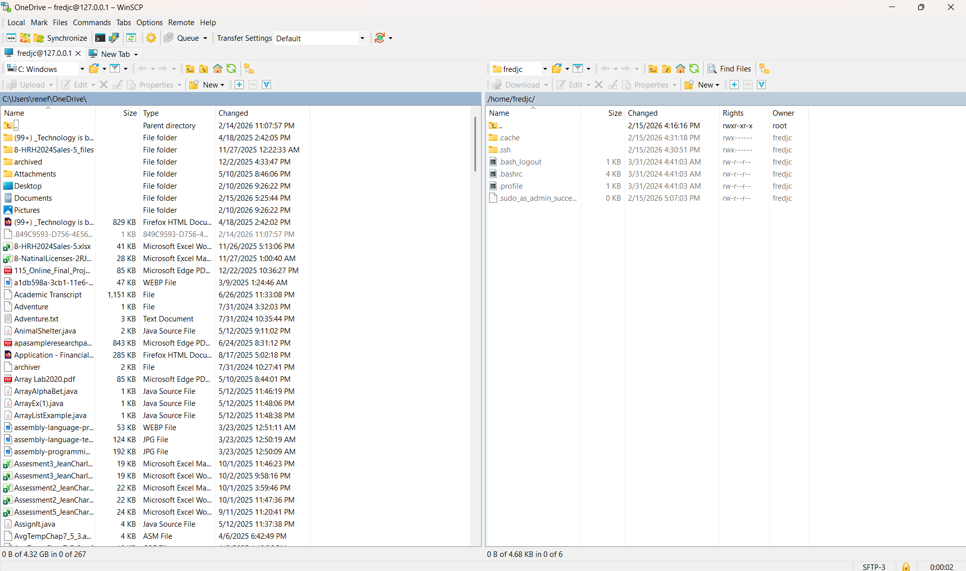

Here the screen after sharing the file.
